**How to Prevent Damage to Your Phone**

The screen on your smartphone is the most appealing feature, but it's also the most susceptible. Accidental drops, exposure to water or other liquids, excessive cold or heat, and other factors are all common causes of phone damage.

The screen of your phone may shatter or scratch if it is subjected to certain of these circumstances. Aside from that, the phone's body can get scratched or damaged. Damage to the smartphone's internal components is a possibility.

This is why, after purchasing a new phone, one of the first things to consider is how to safeguard it from harm. In this article, we'll look at some suggestions for keeping your phone secure and looking tidy at all times.

Using a good screen protector, purchasing a well-designed case, and purchasing a phone protection insurance plan are all options. Continue reading to gain more helpful hints!

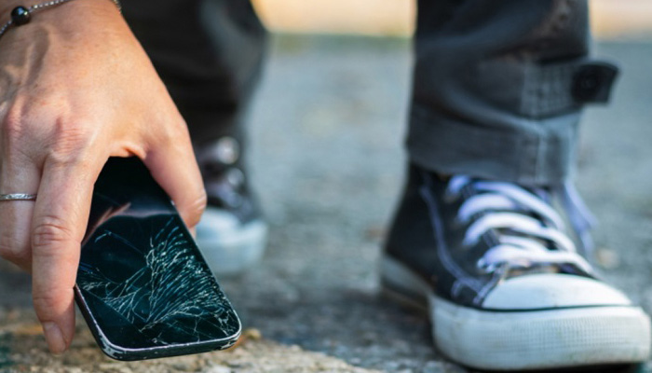

**Buy a Screen Protector**

Scratch- and impact-resistant displays are common on modern smartphones, which are generally made of Gorilla Glass or a similar substance. However, the displays are not unbreakable, necessitating the purchase of a screen protector.

If your keys scratch the screen when the gadget is in your purse or pocket, you may simply buy a replacement protection with that attachment guiding the screen. It's far easier and less expensive to change your screen protector than it is to replace the built-in screen of your smartphone.

Several screen protectors also have an oil-resistant layer that helps to eliminate fingerprints and smudges.

**Make use of a high-quality phone case**

In today's fast-paced and multitasking world, it's possible that you'll drop your phone and damage it. Thankfully, purchasing a phone case can help you prevent this problem.

This equipment will provide optimum physical protection for the smartphone and ensure that its exterior remains as new even after extended use.

**Extreme Conditions should be Avoided**

As you may guess, very hot or cold conditions harm a smartphone. Avoid exposing your phone to extreme heat or cold over an extended length of time.

Exposure to these harsh circumstances might harm the battery and internal components of the device, resulting in reduced battery life, data loss, or the need to purchase a new phone.

Furthermore, intense cold causes certain portions of a phone to become more stiff, making it more susceptible to impact damage. By using common sense, you may avoid this type of harm caused by excessive temperatures.

For example, on a hot day, avoid leaving the phone in direct sunlight or in an unsecured parked car for an extended amount of time.

Don't leave your gadget in your car or an exterior pocket of your jacket/coat on a really cold day. Keep it in an inner pocket instead. As a result, your body heat will keep it warm.

If your phone has been exposed to excessive cold or heat, bring it indoors and gently bring it back to room temperature. This is especially critical if the phone is chilly, since switching from hot to cold too quickly might cause condensation to form within the phone, potentially resulting in water damage.

**Keep a strong grip on your phone**

The most common reason for a phone or tablet falling out of your hand is because you're holding it incorrectly. This is why you must maintain a strong grasp on your smartphone. Because your smartphone or tablet is fairly sensitive, never handle it freely.

**Keep your phone out of the water**

Your smartphone will become wet and malfunction if it comes into touch with water (or other substances). This can happen at the beach, in the rain, or while you're holding the phone in your damp hands (in the pool).

If your smartphone or tablet isn't waterproof, make sure it doesn't come into touch with water. When your phone screen is exposed to misty conditions, it might become damaged.

Avoiding mist exposure on the device screen is the easiest strategy to avoid this problem.

**Locate a reputable phone repair service**

[M6Repairs](https://m6repairs.co.uk/) will give you with high-quality repair if your phone or tablet's screen has to be replaced. Any difficulties impacting your equipment may be resolved by our professionals, who have the necessary expertise and experience.

You can rely on us to provide the best repair service, whether it's a software or hardware issue. To begin, make a reservation on the site and describe the problem you're having with your phone.